Automation Script Execution Guide

Load Eclipse with project

1. install java jdk1.8
2. install eclipse
3. create java project with selenium Java Client libraries
4. download chromedriver
5. download selenium-server-standalone-3.13.0
6. Under ebayProject -> TestData-> Constants.java update URL , product1 and product2

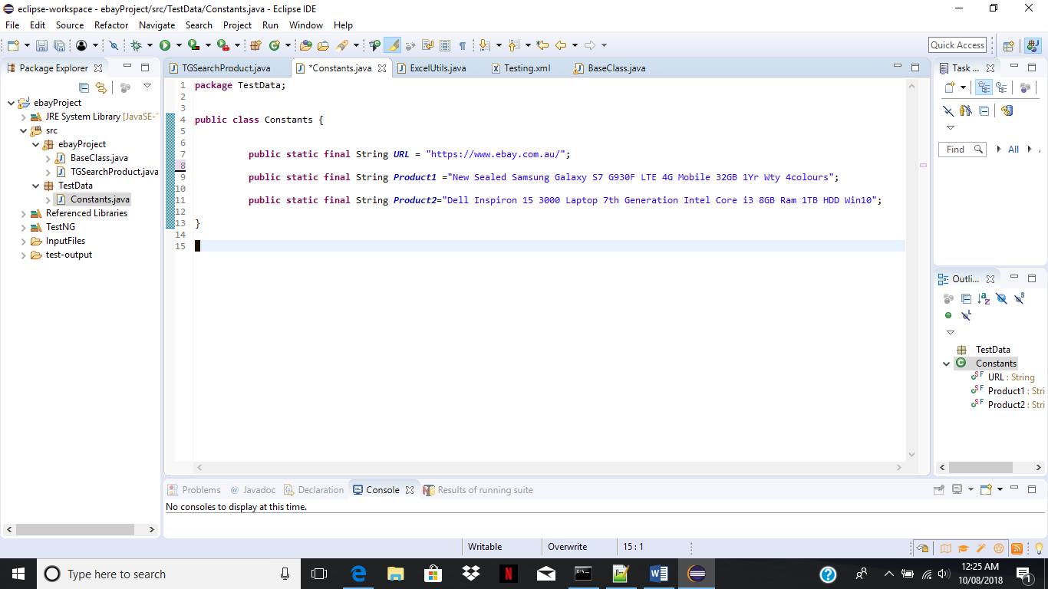

Start Hub and Nodes (Grid Setup)

1. Download “Selenium Standalone Server” from “http://www.seleniumhq.org/download/” on all 3 machines
2. Goto machine 1 and open command prompt.
3. Navigate to location where jar is located.
4. Start Hub by command:  **java -jar selenium-server-standalone-3.13.0 -role hub**
5. Open browser and navigate to **http://localhost:4444/grid/console**and verify hub is started by checking below image.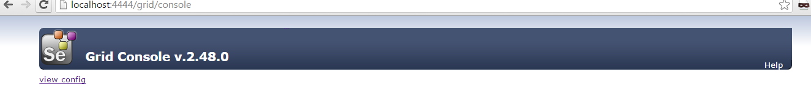
6. Goto machine 2 and open command prompt
7. Navigate to location where jar is located.
8. Start Node by command: **java -Dwebdriver.chrome.driver=**{path to chromedriver.exe}**-jar selenium-server-standalone-3.13.0-role webdriver -hub -port 5560 -browser browserName=chrome,maxInstances=2,maxSession=2**
9. Goto machine 1 and in browser navigate to **http://localhost:4444/grid/console**and verify node is started by checking below image.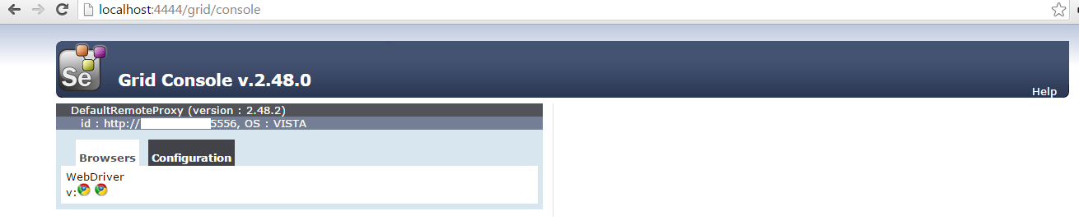
10. Goto machine 3 and open command prompt.
11. Navigate to location where jar is located.
12. Start Node by command: **java -jar selenium-server-standalone-3.13.0-role webdriver -hub -port 5557 -browser browserName=firefox,maxInstances=5,maxSession=2**
13. Goto machine 1 and in browser navigate to **http://localhost:4444/grid/console**and verify node is started by checking below image. 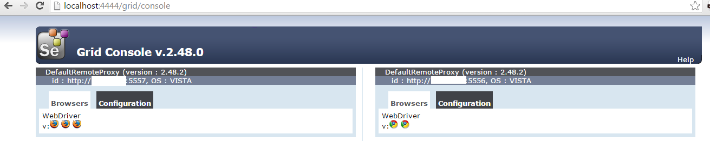
14. Execute testng.xml and execution will start parallelly on both machines.

CI Integration : Jenkins

java -cp bin;LIB/* org.testng.TestNG testing.xml